https://github.com/kubeflow/tf-operator/blob/master/examples/v1/dist-mnist/dist_mnist.py
distribution-tfoperator-kubeflow\examples\v1\dist-mnist

制作镜像主机测试
创建镜像 docker build -f Dockerfile -t kubeflow/tf-dist-mnist-test:4.0 ./
查看镜像 docker images | grep mnist
删除镜像 docker rmi kubeflow/tf-dist-mnist-test:4.0
docker rmi img.ai.ebiot.net/library/tf-dist-mnist-test:4.0
创建容器 docker run -it --rm -h "sfz" --name sfz_temp -v /home:/home kubeflow/tf-dist-mnist-test:4.0
再次进入容器：docker exec -it sfz_temp /bin/bash
验证mnist-train-tensorflow/mnist_train.py可以运行
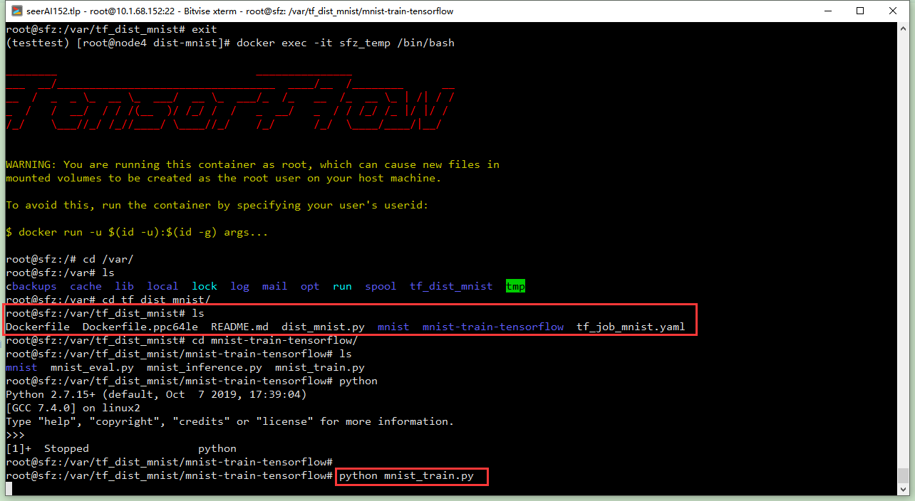
标记镜像docker tag kubeflow/tf-dist-mnist-test:4.0 img.ai.ebiot.net/library/tf-dist-mnist-test:4.0
上传镜像 docker push img.ai.ebiot.net/library/tf-dist-mnist-test:4.0
其他主机测试
# docker pull img.ai.ebiot.net/library/tf-dist-mnist-test:4.0
# docker run -it --rm -h "sfz" --name sfz_temp -v /home:/home img.ai.ebiot.net/library/tf-dist-mnist-test:4.0

Kubeflow测试
6022：
kubectl -n projsfz delete tfjob dist-test-sfz

kubectl -n projsfz get tfjob
kubectl -n projsfz describe tfjob dist-test-sfz
kubectl -n projsfz get tfjob dist-test-sfz -o yaml

kubectl -n projsfz get pods
kubectl -n projsfz describe pod dist-test-sfz-ps-0
kubectl -n projsfz logs -f dist-test-sfz-ps-0
kubectl -n projsfz logs -f dist-test-sfz-work-0
kubectl -n projsfz logs -f dist-test-sfz-work-1

kubectl exec -it -n projsfz dist-test-sfz-ps-0 -- bash
kubectl -n projsfz delete pod dist-test-sfz-ps-0

150gpu:
kubectl create -f ./tf_job_mnist.yaml

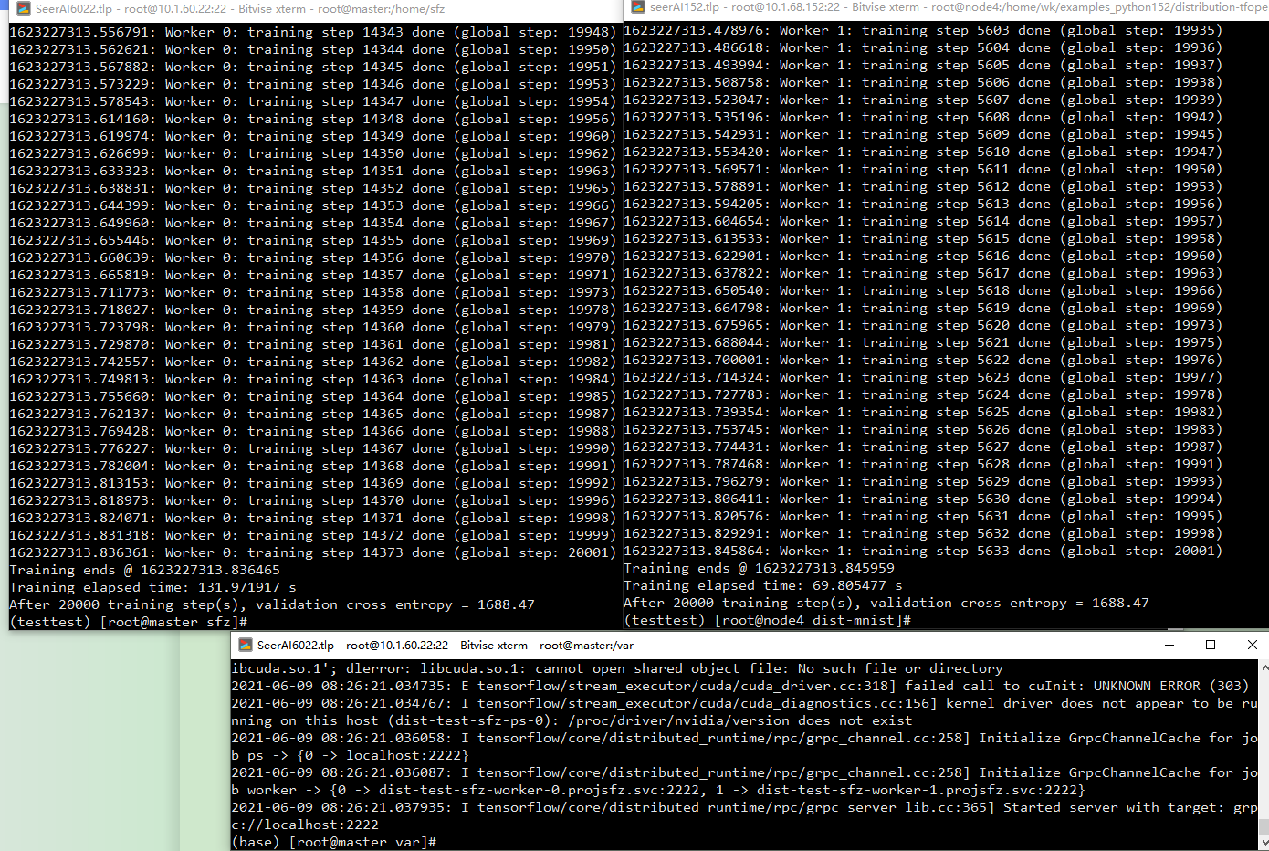
OK

